Adhip Kashyap

# Adhip Kashyap

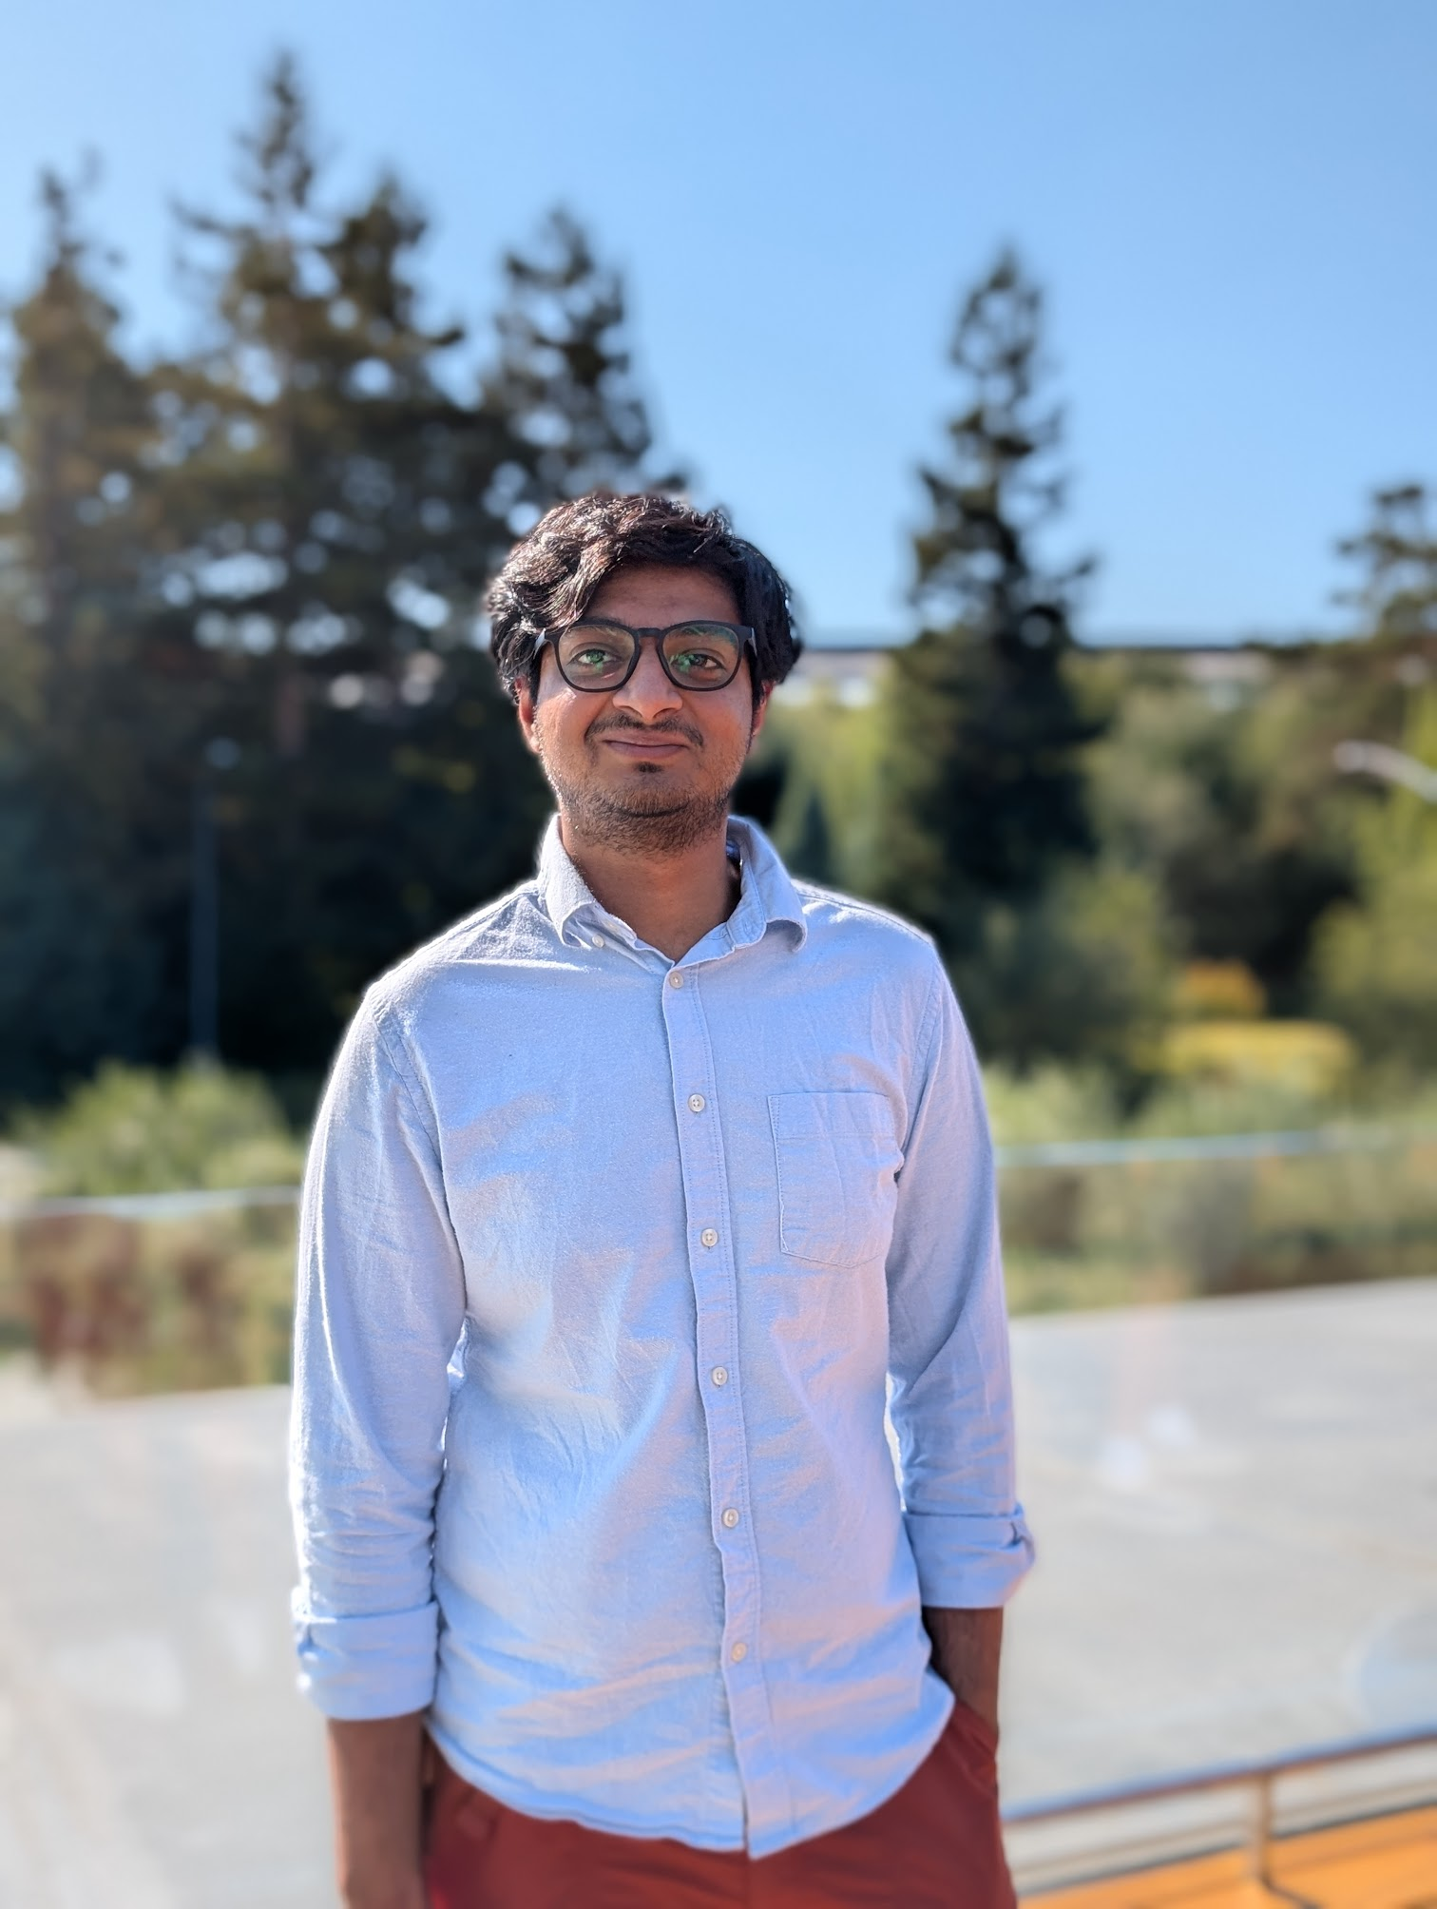

Save PDF

(602)-515-5187 | [adhip.kashyap@gmail.com](mailto:adhip.kashyap@gmail.com) | Thousand Oaks, California

[adhipk.dev](https://adhipk.dev) | [linkedin.com/in/adhip-kashyap](https://linkedin.com/in/adhip-kashyap) | [github.com/adhipk](https://github.com/adhipk)

AI Software Engineer at Hoag Hospital building production AI systems for healthcare automation. M.S. Computer Science from Arizona State University with expertise in AI systems, backend architecture, and autonomous agent design.

## Technologies and Languages

**Languages:** Java, Python, C/C++, TypeScript, Rust, PHP, GoLang, NodeJS.  
**Cloud & DevOps:** AWS (S3, DynamoDB, Lambda, IAM, CloudFormation, SQS, SNS),Azure, Databricks,Github CI/CD, DigitalOcean, Kubernetes, Docker, Terraform, CI/CD, GCP, Azure.  
**Frameworks & Libraries:** Spring Boot, Next.js, React.js, Django, FastAPI, TensorFlow, PyTorch  
**Databases:** MySQL, PostgreSQL, MongoDB, Cassandra, DynamoDB, SQLite  
**Other:** Git, Postman, Bash Scripting, Linux, JIRA, Test-driven Development.

## Work Experience

### Hoag Hospital, Newport Beach, CA

AI Software Engineer

Oct 2025 – Present

*TypeScript, Node.js, Terraform, ElevenLabs, GPT, Deepgram, Vapi, YAML/Markdown Parsers, EHR Epic*

* Developed AI call center agents to automate appointment calls, processing ~3,000 calls with an 80% call deflection rate.
* Developed custom GitOps to manage agent configs using git version control and automated scripts to deploy, simplifying syncing between dev, stage, and prod environments.
* Spearheaded development of comprehensive eval harness with automated customer agent simulation evaluated by judge LLM, including scripts to automate test case creation using existing transcripts for regression testing and compliance reporting.

### TechAhead, Remote

Client Solutions Architect

Apr 2025 – Present

*System Design, Backend Architecture, AI Integration, Cost Analysis*

* Created technical architecture proposals for potential clients and designed scalable backend systems.
* Coordinated with clients and developers to ensure alignment on feature development and project requirements.
* Consulted on AI integration strategies for client projects and developed internal AI tools to automate proposal creation.
* Calculated and optimized system costs for proposed solutions.

### Teaching Solved, Tempe, AZ

Founding Engineer

Aug 2024 – Mar 2025

*Next.js, React, Tailwind, PostgreSQL, AWS Lambda, S3, Stripe, Clerk, Posthog, Google analytics, Sentry*

* Designed and implemented a full-stack platform for teachers to create, share, and sell language resources – integrating authentication, payments, file management, analytics, and error tracking to serve 1,000+ educators.
* Developed a custom RAG solution to enhance search results based on cultural and linguistic relevance.

### InduzBuy, Bangalore, India

Software Engineer Intern

May 2023 – Aug 2023

*Laravel, EC2, BERT, Python, TensorFlow*

* Improved modularity and cut feature lead time by 20% by migrating from core PHP to Laravel.
* Reduced data processing time from 30 mins to 30 secs with a 95% accurate BERT-based model.
* Decreased deployment errors by 40% by automating EC2 deployments via bash scripting.

### ICICI Lombard GIC, Bangalore, India

Software Engineer

Oct 2019 – Aug 2022

*Java, Spring Boot, Neo4j, Redis, SQL, React.js, React Native*

* Reduced AWS costs by 30% by migrating a monolith to microservices with auto-scalers.
* Improved insurance premium computation speed by 40% using a Neo4j-based decision tree.
* Cut call center revenue loss by 20% during COVID by building a React Native CRM app for sales teams.

### Autoninja, Bangalore, India

Software Engineer

Jan 2019 – Oct 2019

*Java, Spring Boot, ELK Stack, Sentry*

* Decreased support calls by 20% by developing real-time car delivery tracking.
* Reduced error response times by 70% by implementing internal ELK dashboards to catch misconfigurations in customer deployments.
* Cut ticket resolution time by 15% by optimizing customer support processes.

## Education

* M.S. Computer Science, Arizona State University, Tempe

2022 – 2024

* B.Sc. Mechanical Engineering (Minor: CS), PES University, Bangalore

2015 – 2019

## Projects

**Open Source MathNotes Application**

Feb 2025

*Python,TensorFlow, tldraw, pic2text, Sympy*

* Created an open-source MathNotes application to automatically solve handwritten university-level mathematical equations with an accuracy of 85%.

**Scalable Data Processing Pipeline**

Jan 2023

*Apache Spark, Kubernetes, Scala, Hadoop, Neo4j*

* Leveraged 10M+ NYC taxi records and created an ETL pipline to model trip patterns using PageRank and hotspot detection.

**TCR-Epitope Binding Affinity Prediction**

Sep 2023

*CNN, Encoder-Decoder, TensorFlow*

* Achieved 81% accuracy on 500k+ antigen sequences with a hybrid CNN-encoder-decoder model.
* Enhanced recall by 8% to improve immunotherapy research insights.